**Steps to running ANOVA in EXCEL**

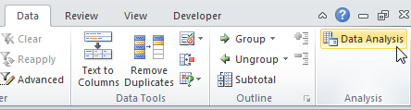

**One way ANOVA**

1. Excel wants your data in side by side columns, one for

|  |  |  |
| --- | --- | --- |
| Group1 | Group2 | Group3 |
| 23 | 56 | 34 |
| 34 | 45 | 76 |
| 65 | 34 | 43 |
| 76 | 65 | 23 |
| 85 | 34 | 37 |
| 34 | 76 | 37 |
| 23 | 24 | 73 |
| 56 | 65 | 85 |
| 76 | 34 | 96 |
| 45 | 23 | 46 |

group or treatment level. Give each column a heading.

1. On the data tab select ***Data Analysis…***

and choose “**ANOVA: Single Factor**.” OK.

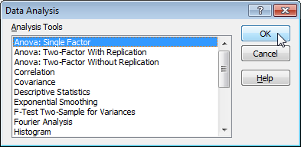

3. Excel asks you for a single range of cells containing ALL

the data.

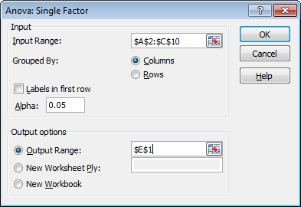

Click the icon, then highlightall three (or more) columns of cells, *including their headings.* Enter.

4. Check the **Labels** box, so Excel knows you included headings atop each column. OK.

5. Excel whips out an Output table.

You can quickly resize the columns by doubleclicking

up top between the A & B, between the B & C, etc. There’s lots of info here,

but all you’re really after is that “Between Groups” pvalue.

The ANOVA partitions the natural variance within the groups (the noise) from the variance between the groups (the signal). If the differences between the groups are substantially greater than the differences within the groups, then we say that there’s a strong “signal to noise” ratio. And the stronger the signal to noise ratio, the lower the pvalue! if F > F crit, we reject the null hypothesis.

**Important Note!** All an ANOVA test can tell you is whether there are statistically significant differences *somewhere* in the data as a whole. But it cannot tell you *just where* those differences lie. The ANOVA itself can only tell you that at least *one* group in there is different from *some other* group in there …but not which ones. Therefore IF (and only if) your Between Groups pvalue falls below 0.05, then you will want to run a second test called a “Multiple Comparisons” test (like Tukey’s test) in order to pinpoint just where the real differences lie. Unfortunately, this is something that Excel can’t do for you.